Accessing Family Portal

FACTS Management gives you, the busy parent, an opportunity to get more involved in your child’s academic progress and future success – all via the Internet!

FACTS Family Portal is a private and secure parents’ portal that will allow parents to view academic information specific to their children, while protecting their children’s information from others. You may view your child’s grades, attendance, homework, and conduct, as well as other useful school information. You can also communicate with teachers and other school staff online whenever necessary.

Here is how to access our easy-to-use Family Portal Online:

- In Chrome, Firefox, Safari, or Internet Explorer go to: bshknights.org/familyportal and click “Sign into FACTS SIS” button.
- Type the BSH’s District Code: BS-VA
- If you are new to Family Portal, Click Create New Family Portal Account
  - Type your email address and click Create Account. An email will be sent which includes a link to create your login. The link is active for 6 hours.
  - From the email, click the link to create your Family Portal (ParentsWeb) login.
  - A web browser displays your Name and FACTS SIS Person ID.
  - Type a User Name, Password, and Confirm the password.
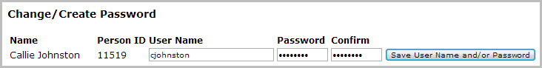
  - Click Save User Name and/or Password.
A message displays at the top of the browser, "User Name/Password successfully updated."
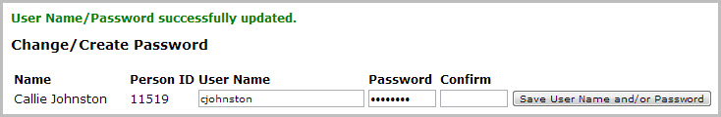
  - You may now log in to Family Portal using your new username and password.
- If you have already created a user account, simply type in the email associated with your Family Portal account and the password. Click the “Parent” button and then “login”

